Court File: T-1450-15

FEDERAL COURT OF CANADA

BETWEEN:

Radu Hociung

Plaintiff

and

Minister of Public Safety and Emergency Preparedness
and
Canada Border Services Agency
and
Her Majesty the Queen in Right of Canada

Defendants

LETTER TO THE COURT
Re: Submissions regarding recusal of Justice Gleeson

Radu Hociung
246 Southwood Drive
Kitchener, Ontario
N2E 2B1
Tel: (519) 883-8454
Fax: (226) 336-8327
email: radu.cbsa@ohmi.org

TO:
The Registrar
Federal Court of Canada
180 Queen Street West
Suite 200
Toronto, Ontario
M5V 3L6

AND TO (by email):
Derek Edwards, Counsel to the Defendant
DEPARTMENT OF JUSTICE
Ontario Regional Office
120 Adelaide Street West
Suite 400
Toronto, Ontario
Tel: (647) 256-7493
Fax: (416) 973-5004
June 5, 2020

Mr. Justice Gleeson,
I am providing the Plaintiff's submissions on your recusal from Federal Court File T-1450-15, as you directed at the June 4, 2020 teleconference.

The Plaintiff is not making a Motion for your recusal, formal, informal or otherwise, in any form. These submissions are only several criteria you should take into account when considering your recusal at your own initiative.
The Plaintiff draws your attention to the Ethical Principles for Judges, specifically Diligence Commentary paragraph 8 (judges must not only deal with matters fairly, but in an fashion that is seen to be fair), and the Impartiality Commentary on Judicial Demeanour paragraph B.1, reproduced below:
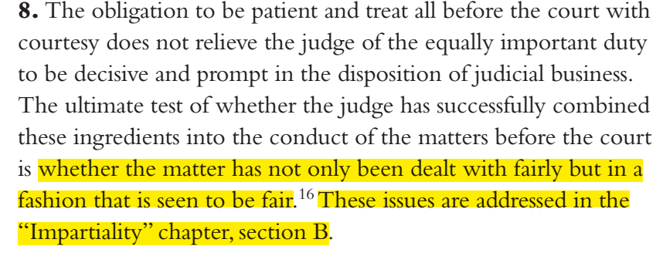

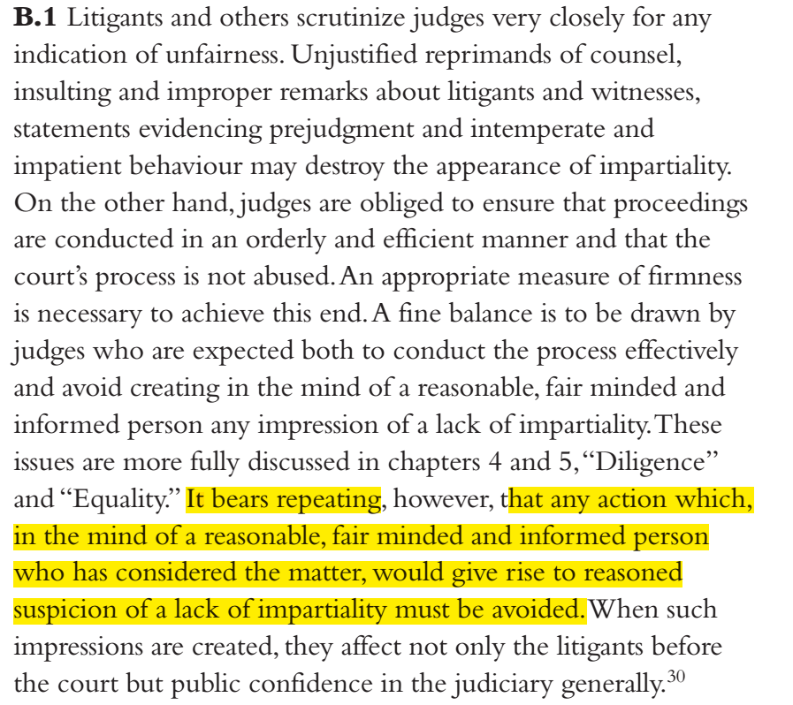
The Plaintiff recommends reading the entire text of the Principles. They inspire in the Plaintiff feelings of confidence in your profession, and expectations of a justice process that does what it says. Your conduct in the proceeding so far, and the intentions you have signalled, however, leave the Plaintiff disgusted with the actual reality. I will point out some of your past misconduct, and your signalled future conduct.

Signalled future partiality

Motions are intended to enable parties to Move the Court to take actions which are within the Rules of the Court, but have the potential of creating prejudice to the parties (ie, advantage/disadvantage which cannot be compensated by costs). On the other hand, Court actions which have no potential of creating prejudice to the parties are permitted by the Rules at the judge's or prothonotary's discretion, with or without motion (ie, at the parties' or the Court's initiative, respectively, per Rule 47). The Plaintiff makes no motion for recusal, as he does not acknowledge that recusal has the potential to cause prejudice. However, as you insist that a motion for recusal must be brought, you are implying that your absence from the proceeding would prejudice a party. Given that so far you've been partial to the Defendant, it is clear that your recusal has the potential to deprive the Defendant's of his means of success in the proceeding. In other words, without your partial judgements, the Defendant may fail in the proceeding. An honest judge would see his recusal as inconsequential to the outcome of the Action, and would therefore not require a Motion for Recusal, but would consider it of his own initiative. In short, the very idea of a “Motion for Recusal” is, in this context, an aberation.

You have indicated that if a “Motion for recusal” were to be made against you, you would be determining that motion yourself. It is a core value of justice that no man can be his own judge. In other words, you further indicated you intend to continue your unethical conduct.

Lack of Objectivity

At the Jun 4 teleconference, you maintained that you believe yourself to be objective and fair, and that you have not attempted to side-step the Rules of the Federal Court. This is easily disproven, as follows.

Your initial judgements on the Motion for Summary judgements were quashed for the reason that you did not follow Rule 106. It was so straight forward for the Federal Court of Appeal to see this fact, that it had no choice but to quash your judgment.
Although the Federal Court of Appeal found your disregarding the Rules of the Court to be sufficient in rendering a conclusion, we could look at your judgment a little more closely to find that you're not even in the remote neighbourhood of Objectivity:

The pivotal evidence on which you relied for your judgment was evidence that did not come from the Defendant, nor the Plaintiff, but from your own self (paragraph 60 of your Summary judgment reasons, ie reliance on Excise Tax Act section 123(1) definition of “money”). In fact, you did not find any of the Defendant's submissions on his Motion helpful in your determination, nor did you consider the Plaintiff's submissions (specifically Plaintiff's Responding submissions, paras 65, 143, 144 and 218, which directly contradict your paragraph 60, by showing how the Currency Act plainly states that the coins cannot be used as anything other than as currency, ie, by statute, they are not “goods”). It was not the least bit objective of you to ignore the Plaintiff's evidence before you, overlook that the Defendant had nothing constructive to offer in making his case, or in you providing the “missing” piece of evidence yourself. You've done all this in order to arrive at the outcome requested by the Defendant, in a most partial fashion.

March 2, 2020 Order

Your March 2, 2020 is prejudicial to the Plaintiff, and in favour of the Defendant. You've further demonstrated a lack of justice.
Rule 390 requires a motion for staying a proceeding, and further permits only a Case Management Judge or Case Management Prothonotary to stay the proceeding, and further permits a stay only on grounds of alternative means of dispute resolution. In spite of these requirements, you ordered the proceeding stayed, by using alternative language as “abeyance”. You ignored the Rules and made this order based on the Defendant's informal (and later abandoned) request.
In “Directions” issued around the same date, you made up a Rule that the Plaintiff would have to pursue your recusal by way of motion. Such a rule does not exist.
These two facts demonstrate that you are partial to the Defendant. To overlook the Rules to one party's benefit, while raising made-up rules to block the other party's request, is clearly biased/partial.
Furthermore, in your Order, you invoked “plenary powers to manage their processes and proceedings”, quoting Lee v. Canada (Correctional Service), 2017 FCA 228 paras 7 and 8. The Federal Court does not have such “plenary powers”. The Federal Court of Appeal interpreted the Supreme Court 1998 CanLII 818 (SCC), [1998[ 1 S.C.R. 626, 224 N.R. 241, paras 35-36. This authority speaks of “plenary jurisdiction” (as opposed to “inherent jursidiction” and “residual jurisdiction”) of the Federal Court, with the meaning that the Federal Court does have jurisdiction to grant injunctions in support of the Human Rights Act. The word “plenary” was not used in any context like “plenary powers to manage proceedings”. Even a moment's due diligence on your part would have lead you to the question “If the court has plenary powers, what is the role of Rules that explicitly specify powers of the Court?”. Although you did not originate the term “plenary powers”, you failed to be objective by not looking into the Authority that was claimed by the Federal Court of Appeal, but used it because it suited your goal of helping the Defendant.
In your rush to help the Defendant obtain the stay he wanted, you mistakenly seized on the word “plenary” as your overriding source of powers, and took it out of the context of the Supreme Court's ruling.
Furthermore, as the Plaintiff pointed out in subsequent letters, obtaining a “Leave to Appeal” to the Supreme Court is not the same as a proceeding being commenced in the Supreme Court. As I stated, my intention was to wait for the determination of the two motions before commencing the Supreme Court appeal, if leave were granted. Therefore, if a leave had been granted, the T-1450-15 proceeding would be in a state of deadlock (stayed pending resolution of a proceeding that would not exist until the T-1450-15 proceeded). It is my right to decide when to commence proceedings. In your rush to help the Defendant', you've caused the Plaintiff prejudice. Fortunately, the Leave to Appeal was rejected, so even according to your partial Order, the prejudice was limited to time wasted unnecessarily.

Mr J Gleeson, these submissions are not the entirety of the reasons why you've demonstrated to be a crooked judge, but given that you'll be judging yourself, and that I'm not required to persuade you, but at best give you a starting point for your own evaluation of your ability and willingness to conduct yourself ethically, I see no need to persuade you. An honest judge which is close to crossing the line would find these argument sufficient to recuse himself. On the other hand, a judge that is deeply corrupt would find no argument sufficient to act ethically. Unfortunately, you've convinced the Plaintiff that you are the latter.

If you want technical terms, per the Ethics Principles, “a suspicion of a lack of impartiality must be avoided”. I hope I have shown that your lack of impartiality is reasonably suspected, and that to avoid further lack of impartiality, you must recuse yourself. For extra clarity, the Plaintiff suspects you are associated with the organization that is using the CBSA to launder money.

I would like to close by reiterating the point that the Ethics Principles already iterates multiple times, that is that it's not your view of yourself that matters, but the view of “a reasonable, fair minded and informed person”. Your decision to recuse yourself should be based on how you are perceived by such a person. In this case, there is no need for you to speculate how a reasonable, fair minded and informed person would perceive you. As an informed person, and for the reasons I've already given you, I am telling you directly, that I perceive you as a corrupt, crocked judge to such an extreme extent that not only I raise this complaint, but I am convinced you've crossed into criminal territory, and am willing to pursue charges against you. You've created in my mind an image where the Federal Court is a circus, not a court of justice, and I am nothing but a naive, and unwilling protagonist, the audience member that is unwittingly selected to be fed to the sharks in the pool. Had I known that the reality of the Federal Court is as disgusting as it is, I would have approached this dispute differently.

Sincerely,

Radu Hociung - Plaintiff

Ethical Principles for Judges, https://cjc-ccm.ca/cmslib/general/news_pub_judicialconduct_Principles_1998_en.pdf
https://www.canlii.org/en/ca/scc/doc/1998/1998canlii818/1998canlii818.html

